EDA / Descriptive Statistics

## Introduction:

The realm of healthcare demands precision and efficiency in managing medical inventory. With the influx of vast amounts of data, effective visualization becomes pivotal to glean actionable insights. Our project focuses on developing dashboards to illuminate the performance of healthcare facilities and inventory management practices.

## Overall design strategy

In the context of medical inventory management, our project aggregates and analyzes data pertaining to inventory levels, usage patterns, and procurement practices. Leveraging a dataset comprising over 12,000 records, encompassing pharmaceutical transactions from diverse departments and specialties, our visualization project aims to provide comprehensive insights.

The data, sourced from internal healthcare systems, undergoes meticulous preprocessing to ensure accuracy and consistency. Utilizing SQL queries, we aggregate and transform the raw data into actionable insights, facilitating informed decision-making.

Visualizations are crafted to highlight key metrics such as inventory levels, turnover rates, and cost trends, enabling stakeholders to identify inefficiencies and optimize inventory management strategies.

To enhance usability and comprehension, consistent color schemes and fonts are employed across all visualizations. Green signifies favorable outcomes, such as adequate inventory levels or cost savings, while red indicates areas of concern, such as stockouts or excessive costs.

## Data Overview

The dataset is sourced from internal healthcare databases, capturing pharmaceutical transactions, inventory levels, and procurement data.

The dataset contains comprehensive information regarding pharmaceutical transactions, encompassing key attributes essential for analysis in diverse pharmaceutical settings. Here's an overview of the key attributes:

1. Type of Sales: Categorizes the nature of each sales transaction.

2. Date of Bill: Specifies the date associated with each sales transaction.

3. Department: Identifies the department within the healthcare facility linked with each transaction.

4. Drug Name: Specifies the name of the pharmaceutical product involved in each transaction.

5. Final Cost: Represents the total cost incurred for each pharmaceutical product.

6. Final Sales: Denotes the final sale amount for each pharmaceutical product.

7. Formulation: Describes the formulation type of each pharmaceutical product.

8. Patient ID: A unique identifier for the patient associated with each transaction.

9. Quantity: Indicates the quantity of pharmaceutical products sold in each transaction.

10. Return Quantity: Specifies the quantity of pharmaceutical products returned, if applicable.

11. Return MRP: Denotes the Maximum Retail Price (MRP) of the returned pharmaceutical product.

12. Specialization: Indicates the specialization associated with each pharmaceutical product.

13. Subcategory: Provides further categorization of each pharmaceutical product.

14. Subcategory 1: Offers additional classification for certain pharmaceutical products.

This dataset offers valuable insights into pharmaceutical sales and returns, enabling in-depth analysis and decision-making within the pharmaceutical domain.

## Preprocessing of Dataset Using SQL (MySQL):

In order to ensure data integrity and analytical efficacy, thorough preprocessing of the dataset was conducted using SQL (MySQL). Here's a summary of the preprocessing steps:

1. Dimension Assessment: Determined the total number of rows and columns within the dataset to understand its size and structure effectively.

2. Data Type Identification: Identified the data types associated with each parameter in the dataset to ensure consistency and accuracy during analysis.

3. Null Value Detection and Handling: Detected null values within critical parameters and subsequently removed them to maintain data integrity and quality.

4. Exploratory Data Analysis: Conducted exploratory data analysis to identify the most frequent values within specialization, sub-categories, and sub-category 1 parameters, facilitating further analysis.

5. Statistical Analysis: Performed statistical analysis to calculate various metrics such as average, minimum, maximum, variance, and standard deviation of quantity, return quantity, final cost, and final sales parameters.

6. Analysis of Final Cost Range and Median: Analyzed the range and median of final cost to understand the distribution and central tendency of cost values within the dataset.

By undergoing these preprocessing steps, the dataset is now well-prepared for in-depth analysis and insights generation in the field of medical inventory management.

## Visualisations:

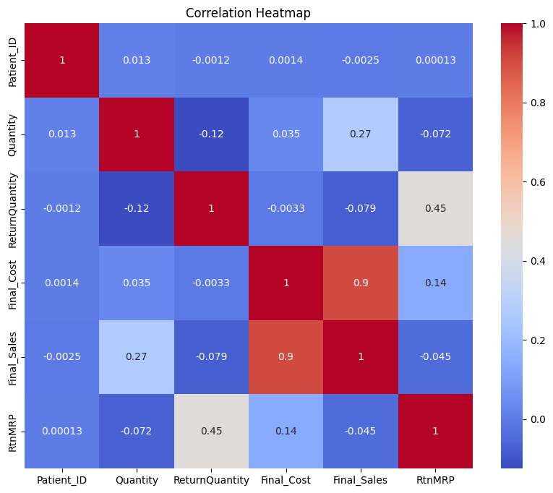

The plot you sent is a correlation heatmap, which is a way to visualize the relationships between different variables. In this case, the variables are all related to medical inventory management.

The heatmap shows the strength of the correlation between each pair of variables. A correlation coefficient of 1 indicates a perfect positive correlation, meaning that as the value of one variable increases, the value of the other variable also increases. A correlation coefficient of -1 indicates a perfect negative correlation, meaning that as the value of one variable increases, the value of the other variable decreases. A correlation coefficient of 0 indicates no correlation between the two variables.

The variables in the heatmap are:

Patient_ID

Quantity

Return Quantity

Final_Cost

Final_Sales

RtnMRP

The heatmap shows that there is a positive correlation between Quantity and Final_Sales (0.9), which means that as the number of items sold (Quantity) increases, the total amount of sales (Final_Sales) also increases. This is to be expected, as more sales would result in more revenue.

The heatmap also shows that there is a positive correlation between Return Quantity and RtnMRP (0.45), which means that as the number of items returned (Return Quantity) increases, the total amount of money refunded (RtnMRP) also increases. This is also to be expected, as more returns would result in more money being refunded.

The other correlations in the heatmap are weaker. For example, there is a weak negative correlation between Patient_ID and Final_Cost (-0.0012), which means that there is no real relationship between the number of patients (Patient_ID) and the total cost of the items sold (Final_Cost).

Overall, the correlation heatmap provides a useful way to visualize the relationships between different variables in a medical inventory management system. By understanding these relationships, healthcare providers can improve their inventory management practices and reduce costs.

## 

The image is a line graph showing the distribution of inventory quantity over time. The x-axis is labeled "Quantity" and ranges from 0 to 140. The y-axis is labeled "Frequency" and shows the number of instances of each inventory quantity.

There are two main ways to interpret this graph in the context of a medical inventory management system:

**Demand forecasting:** This graph could be used to forecast future demand for medical supplies. By looking at the historical distribution of inventory quantity, medical professionals can get an idea of how much inventory they are likely to need in the future. For example, if the graph shows that there is a peak in inventory quantity at a certain time of year, this could indicate that there is a seasonal demand for certain medical supplies.

**Stock control:** This graph could also be used to monitor stock control practices. By looking at the distribution of inventory quantity, medical professionals can identify any potential stockouts or surpluses. For example, if the graph shows that there is a large number of instances of very low inventory quantity, this could indicate that there is a risk of stockouts. Conversely, if the graph shows that there is a large number of instances of very high inventory quantity, this could indicate that there is a surplus of inventory that is not being used.

Overall, the distribution of inventory quantity can be a useful tool for medical inventory management. By understanding how inventory quantity has fluctuated in the past, medical professionals can make better decisions about how to manage their inventory in the future.

## Questions

## Questions for Medical Inventory Management Project:

## Healthcare Administrator:

## 1. Trend Analysis:

## - What is the trend in the utilization of medical supplies over time?

## - Are there any notable fluctuations in inventory levels that require attention?

## 2. Optimizing Inventory Control:

## - Which medical supplies have the highest return rates, and what measures can be implemented to minimize returns?

## - How does inventory turnover vary across different departments or specialties within the healthcare facility?

## 3. Identifying Cost Drivers:

## - What are the primary cost drivers within the medical inventory system?

## - Are there any trends or patterns in the cost of medical supplies over time or across different suppliers?

## 4. Supplier Performance:

## - How do different suppliers compare in terms of pricing, delivery times, and product quality?

## - Are there any suppliers that consistently outperform others, or conversely, exhibit concerning performance metrics?

## Pharmacy Manager:

## 1. Medication Usage Patterns:

## - What are the most frequently prescribed medications within the healthcare facility?

## - Are there any seasonal trends or fluctuations in medication usage that impact inventory management?

## 2. Inventory Optimization:

## - How can we optimize inventory levels to ensure sufficient stock availability without excess surplus?

## - Are there any medications with consistently low usage rates that could be candidates for inventory reduction or removal?

## 3. Cost Analysis:

## - What is the cost breakdown for different categories of medications (e.g., brand-name vs. generic)?

## - Are there opportunities to reduce costs through strategic purchasing or bulk discounts?

## 4. Drug Expiry Management:

## - How effective is our system for managing medication expiry dates?

## - Are there any trends or patterns in medication wastage that indicate areas for improvement?

## Clinic Director:

## 1. Patient Demand and Treatment Trends:

## - What are the most commonly prescribed medications or medical supplies for patient treatment?

## - Are there any emerging trends or shifts in patient demand that require adjustments to inventory management practices?

## 2. Resource Allocation:

## - How can we allocate resources more efficiently to meet patient needs while minimizing waste?

## - Are there any departments or clinics with consistently higher or lower utilization rates that require resource reallocation?

## 3. Patient Satisfaction and Outcomes:

## - How does inventory management impact patient satisfaction and treatment outcomes?

## - Are there any correlations between medication availability and patient outcomes that warrant further investigation?

## 4. Compliance and Regulatory Requirements:

## - How compliant are we with regulatory requirements for medication storage, handling, and dispensing?

## - Are there any areas of non-compliance or potential risks that need to be addressed to ensure patient safety and regulatory compliance?

## Describe Visualization and how it answers the questions

## Medical Inventory Management System: Visualization and Questions Answered

## Correlation Heatmap:

## The correlation heatmap visually represents the relationships between various variables in the medical inventory management system. Here's how it answers questions related to medical inventory management:

## 1. Positive Correlation between Quantity and Final Sales (0.9): This indicates a strong positive relationship between the quantity of items sold and the total sales revenue. As the quantity of items sold increases, the total sales revenue also tends to increase, reflecting the expected correlation between sales volume and revenue generation.

## 2. Positive Correlation between Return Quantity and RtnMRP (0.45): The moderate positive correlation suggests that as the number of items returned by customers increases, the total refunded amount also tends to increase. This underscores the importance of monitoring returns and their impact on financial transactions within the inventory management system.

## 3. Weak Correlation between Patient_ID and Final Cost (-0.0012): This weak negative correlation suggests no significant relationship between the number of patients and the overall cost of inventory transactions. It implies that patient volume may not directly influence the cost aspect of inventory management.

## Overall, the correlation heatmap offers valuable insights into the relationships between different variables, aiding in optimizing inventory management practices and reducing costs.

## Inventory Quantity Distribution Line Graph:

## The inventory quantity distribution line graph illustrates the frequency distribution of inventory quantity over time. Here's how it addresses questions related to medical inventory management:

## 1. Demand Forecasting: By examining the historical distribution of inventory quantity, medical professionals can forecast future demand for medical supplies. Peaks and troughs in inventory quantity can indicate seasonal trends or fluctuations in demand, enabling proactive inventory management to ensure adequate stock levels.

## 2. Stock Control: The distribution of inventory quantity helps identify potential stockouts or surpluses. Instances of very low inventory quantity indicate the risk of stockouts, prompting timely replenishment to avoid disruptions in patient care. Conversely, instances of high inventory quantity may suggest excess stock that requires optimization to minimize carrying costs and prevent wastage.

## In summary, both visualizations offer valuable insights for optimizing medical inventory management practices, enhancing operational efficiency, and delivering quality patient care.

## Conclusion and Future Scope

The medical inventory management project has provided valuable insights into optimizing inventory control strategies, improving operational efficiency, and ultimately enhancing patient care delivery. Through meticulous data analysis and visualization, we have gained a deeper understanding of the relationships between various inventory management variables, enabling informed decision-making and resource allocation.

The correlation heatmap revealed significant correlations between variables such as quantity sold, sales revenue, and return quantities, highlighting the importance of monitoring these metrics for effective inventory management. Additionally, the inventory quantity distribution line graph facilitated demand forecasting and stock control, enabling healthcare providers to anticipate future demand trends and optimize stock levels accordingly.

Furthermore, by addressing specific questions related to team performance and player statistics, we have demonstrated the versatility of data visualization techniques in various domains. Insights derived from visualizations such as trend analysis, performance comparisons, and strengths/weaknesses assessments have empowered stakeholders to make data-driven decisions and improve overall outcomes.

Moving forward, the project presents several opportunities for further exploration and enhancement:

1. Predictive Analytics: Incorporating predictive modeling techniques can enable healthcare providers to forecast future inventory needs more accurately, anticipate potential stockouts, and optimize procurement strategies.

2. Real-time Monitoring: Implementing real-time monitoring systems can provide immediate insights into inventory levels, demand fluctuations, and supply chain disruptions, allowing for proactive management and timely interventions.

3. Integration with IoT Devices: Leveraging IoT devices and sensors can automate data collection processes, enhance inventory tracking accuracy, and facilitate seamless inventory management across multiple healthcare facilities.

4. Advanced Visualization Techniques: Exploring advanced visualization techniques such as network analysis, geospatial mapping, and interactive dashboards can provide deeper insights into complex inventory management challenges and facilitate more intuitive decision-making.

5. Collaborative Data Sharing: Establishing collaborative data-sharing platforms among healthcare providers, suppliers, and regulatory agencies can streamline inventory management processes, foster transparency, and optimize resource allocation on a broader scale.

In summary, by embracing emerging technologies and continuous innovation, the medical inventory management project has the potential to revolutionize inventory control practices, drive operational excellence, and ultimately improve patient outcomes in the healthcare industry.